**Aim 1(a) Introduction to Network Simulator: NS2, OMNET++, OPNET**.

1. **NS2:**

NS2 stands for Network Simulator Version 2. It is an open-source event-driven simulator designed specifically for research in computer communication networks.

**Features of NS2:**

1. It is a discrete event simulator for networking research.

2. It provides substantial support to simulate bunch of protocols like TCP, FTP, UDP, https and DSR.

3. It simulates wired and wireless network.

4. It is primarily Unix based.

5. Uses TCL as its scripting language.

6. Otcl: Object oriented support

7. Tclcl: C++ and otcl linkage

8. Discrete event scheduler

**Basic Architectute:**

NS2 consists of two key languages: C++ and Object-oriented Tool Command Language (OTcl). While the C++ defines the internal mechanism (i.e., a backend) of the simulation objects, the OTcl sets up simulation by assembling and configuring the objects as well as scheduling discrete events. The C++ and the OTcl are linked together using TclCL.

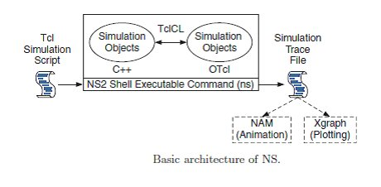

1. **OMNET++**

OMNET++ a discrete event network simulator. It composed of component based C++ simulation library and frameworks. An important component of OMNET++ is component architecture of simulation model. We use network description language to define structure and simulate model requirements for each user. NED provides various features for OMNET++ simulation student projects such as hierarchical, interfaces and component based packages.

OMNET++ a public source, component based open architecture simulation with strong GUI to design discrete event system. We offer OMNET++ simulation source code to handle multiple fixed and mobile nodes and communication links, workload, security issues and routing model. We provide OMNET++ a discrete event simulation tool used by academic and research oriented projects. We enhance OMNET++ simulation source code as fully programmable and modular to design reusable components. By simulation code on OMNET++ we display network graphics output and animated message flow.

**OMNET++ Characteristics:**

1. We adopt following characteristics in OMNET++ are:
2. Run on Linux and Windows.
3. Expandable in Nature by Adding New Components in Libraries.
4. Provide Trace and Debugging Function for Simulation.
5. Focused in Communication Networks.
6. Support GUI to Display Output.

Physical link model is used to establish new communication networks. After network communication it transmit packet to validate system performance. We establish connections by following parameters are propagation rate, bit rate, data rate and packet error rate. We use OMNET++ to differentiate channel type based on parameters. Parameters are as string, numeric or Boolean values.

1. **OPNET:**

OPNET Network simulator is a tool to simulate the behavior and performance of any type of network. The main difference Opnet Network Simulator comparing to other simulators lies in its power and versatility. IT Guru provides pre-built models of protocols and devices. It allows you to create and simulation different network topologies. The set of protocols/devices is fixed – you cannot create new protocols nor modify the behavior of existing ones.

**ADVANTAGES:**

1. Opnet Network Simulator is a open free software
2. Large number of project scenarios that are offered information on Opnet Network Simulator
3. Can be overlooked using Opnet Network Simulator.

**USES:**

1. Operational validation.
2. Application troubleshooting.
3. Network planning and design.
4. Validating hardware architecture.
5. Protocol modeling.
6. Traffic modeling of telecommunication networks.
7. Evaluating performance aspects of complex software systems.

**1(b) Installation steps of NS2, OMNET++, and OPNET**

1. **NS2**

NS2 builds and runs under windows using Cygwin. Cygwin provides Linux like environment under windows.

**SYSTEM REQUIREMENTS:**

A computer with C++ compiler. Building full NS2 package requires large memory space approximately 250MB

**Steps to install NS 2 on windows 7 are given below:**

1. Download Cygwin from following link https://www.cygwin.com/setup.exe

2. Run the downloaded setup.exe and you will see screen shown below click next.

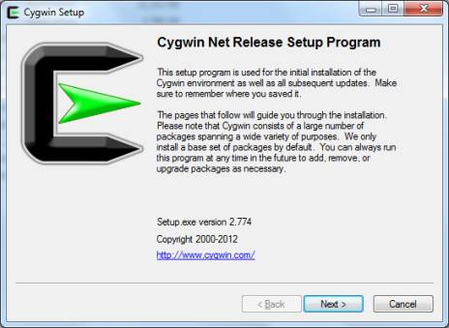

3. Select option "Install From Internet". If you have already downloaded the package select "Install from local directory" and click next

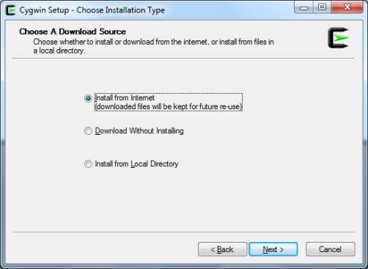

4. Keep the default installation directory as "C:\cygwin" and click next

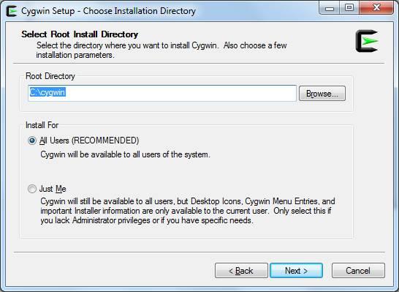

5. Keep default local package directory as your download folder and click next.

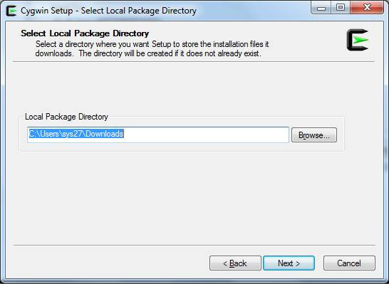

6. Next screen will ask for your Internet connection type keep it as "Direct connection" and click next and in next screen choose one site to download the packages and click next.

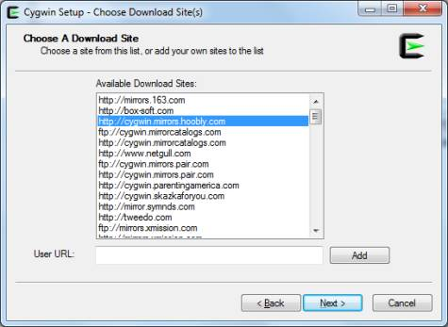

7. In next screen Cygwin will allow to select the packages you want to install

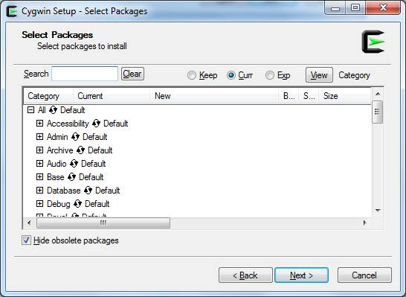

8. Uncheck the option "Hide obsolete packages" then click on "view" button till the word "category" changes to "Full"

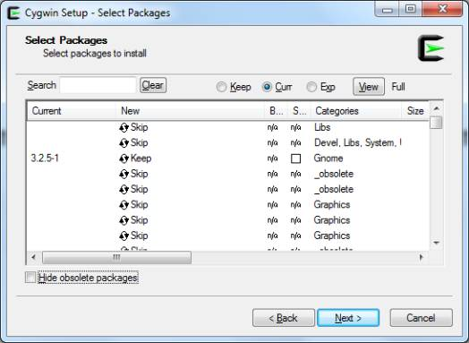

To install NS2 you need to select and install following packages:

1. gcc
2. gcc-g++
3. gnuplot
4. make
5. patch
6. perl
7. tar
8. X-startup-scripts
9. xorg-x11-base
10. xorg-x11-bin
11. xorg-x11-devel
12. xorg-x11-bin-dlls
13. xorg-x11-bin-lndir
14. xorg-x11-etc
15. xorg-x11-fenc
16. xorg-x11-fnts
17. xorg-x11-libs-data
18. xorg-x11-xwin
19. libxt-devel
20. libXmu-devel

To select a package search the package name and click on word "skip" this will change it to version number of the package. Do this for all above packages and click next to start download and installation

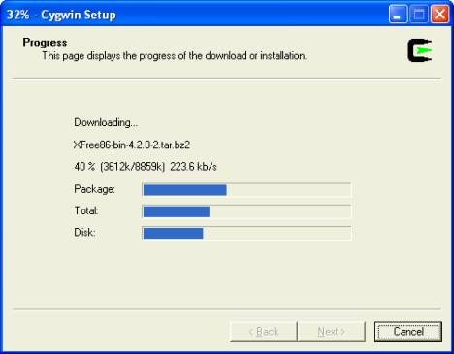

9. Once installation is complete create desktop icons if you need.

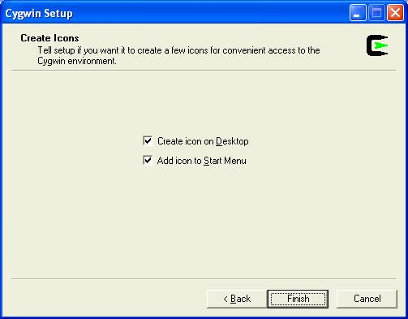

10. Cygwin installation is complete now you can run Cygwin from desktop and see its interface.

1. **OMNET++**

#### STEP 1: DOWNLOAD THE OMNETPP-5.0B2 VERSION IN ONLINE.

#### STEP 2: DOWNLOAD OMNETPP-5.0B2-SRC-WINDOWS.ZIP SOFTWARE AFTER GO TO DOWNLOAD LOCATION.

#### STEP 3: omnetpp-5.0b2-src-windows.zip EXTRACT THE FILE INTO C:\

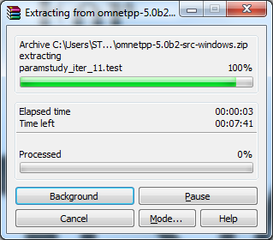

#### STEP 4: NEXT GO TO EXTRACT THE LOCATION (C:omnetpp-5.0b2) TO DOUBLE CLICK THIS FILE “mingwenv.cmd”

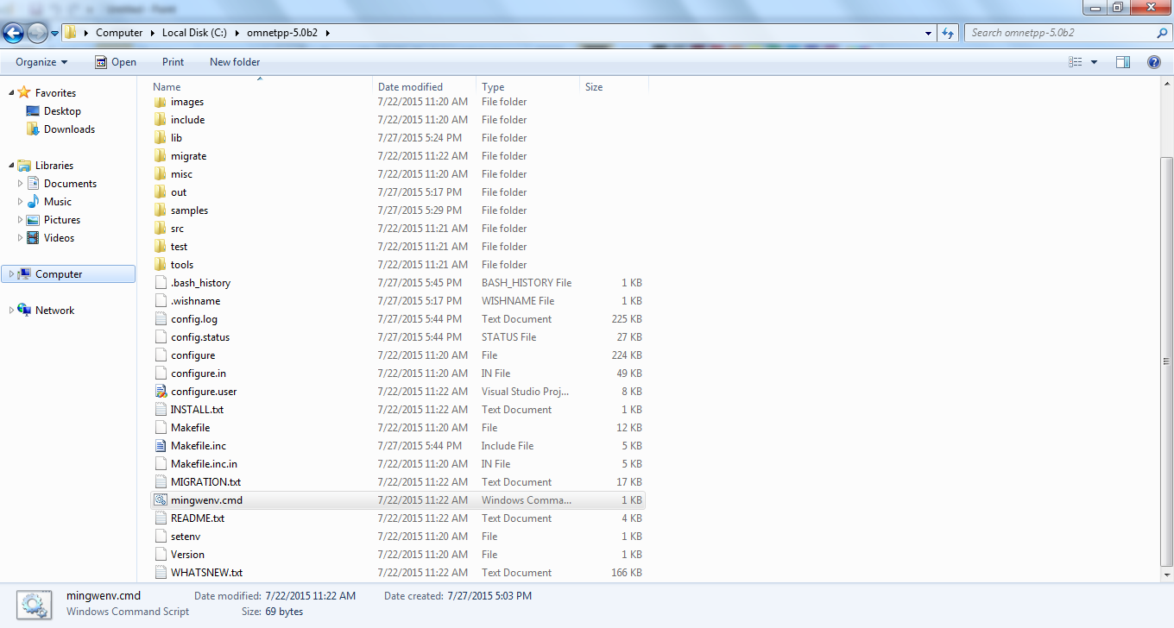

#### STEP 5: NOW OPEN THE mingwenv command WINDOW TO INSTALL OMNET

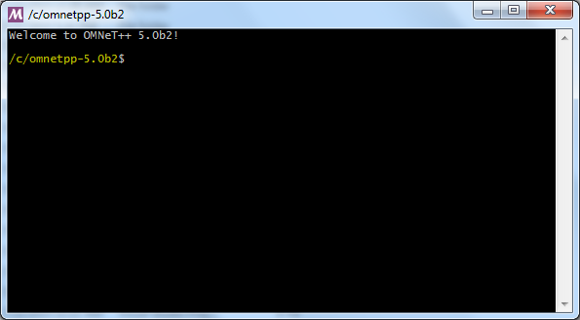

#### STEP 6: SET THE ENVOIRNMENT USE THIS COMMAND “. setenv”

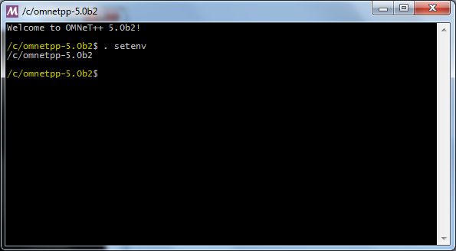

#### STEP 7: CONFIGURE THE OMNETPP INTO YOUR SYSTEM USE THIS COMMAND IS “./configure”

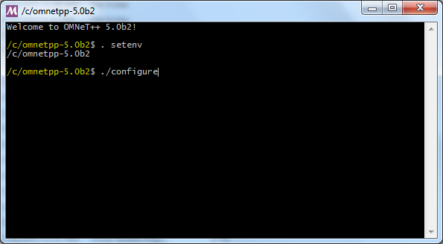

STEP 8:NEXT ENTER make COMMAND.

#### STEP 9: AFTER INSTALL ALL FILES TYPE “omnetpp” TO START THE OMNET IDE.

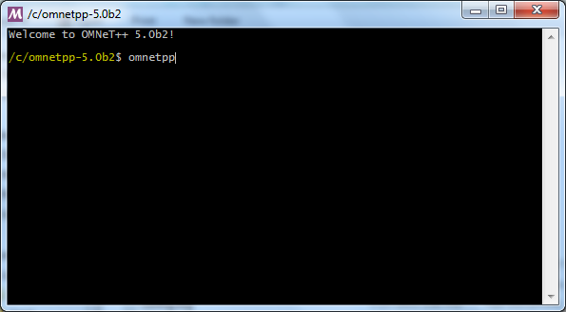

1. **OPNET:**

1. Install C++ and .net from Visual Studio 2005.

2. Install the OPNET files with below order:

Modeler_140_PL3_6313_win.exe

Models_140A_PL3_17Oct07_win.exe

Modeler_docs_140A_PL2_24-Sep-2007_win.exe

3.After installing successfully, set system environments using

My computer->properties->advanced->environment variables and then add system

environments for OPNET to it.

And the installation is completed.

**1(c) Comparison between NS2, OMNET++, OPNET**

|  |  |  |  |
| --- | --- | --- | --- |
| **S.no**. | **NS2** | **OMNeT++** | **OPNET** |
| 1. | It was developed in 1989. | Current version of OMNeT++ is 4.6 which was released in 2014. | It was created in 1986 and latest version of OPNET modeler suite is 18.0.3 which was released in 2015. |
| 2. | It can run on Linux, FreeBSD, MAC OS X, Solaris and windows also using Cygwin software. | It can run on Windows, Linux and MAC OS X. | It can run on both Windows (32-bit as well as 64-bit) and Linux. |
| 3. | It consist of two languages: C++ and OTcl. | Based on C++. | It is also based on C++. |
| 4. | Developed by DARPA and now NSF is also contributing to its development. | Developed by OMNeT++ Developers Groups | Developed by OPNET Inc. and now taken over by Riverbed. |
| 5. | It supports text-based and graphical based both outputs. | It includes Eclipse based IDE which enables debugging of modules and graphical and text editing of files. | It gives us an GUI interface to build network scenarios and enables its text testing. |
| 6. | It provides support for protocols like 802.11, 802.16, 802.15.4, IR-UWB etc. | It focuses on improving the uses of Graphical Runtime Environment. | It also supports Wireless Sensor Networks and comprise of NetDoctor, ACE and MVI. |
| 7. | Takes moderate time to download and install. | Very less time to download and install. | Moderate time to download and install. |